# W1

## Computer Vision

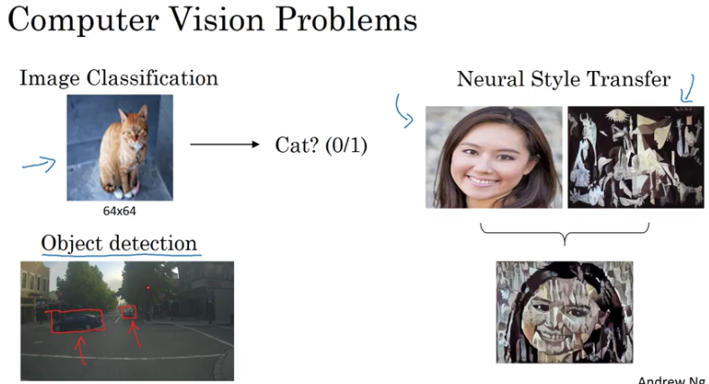 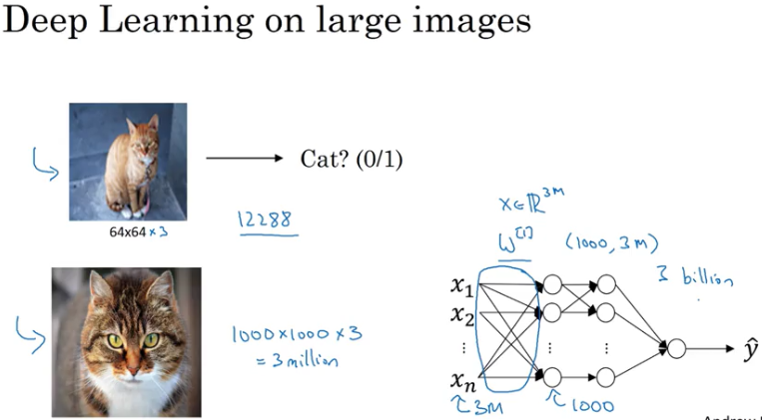

This matrix will be a 1000 by 3 million dimensional matrix. Because X is now R by three million.And this means that this matrix here will have three billion parameters which is just very, very large. And with that many parameters, it's difficult to get enough data to prevent a neural network from overfitting. And also, the computational requirements and the memory requirements to train a neural network with three billion parameters is just a bit infeasible.

For computer vision applications, you don't want to be stuck using only tiny little images. You want to use large images. To do that, you need to better implement the **convolution operation**, which is one of the fundamental building blocks of convolutional neural networks.

## Edge Detection Example

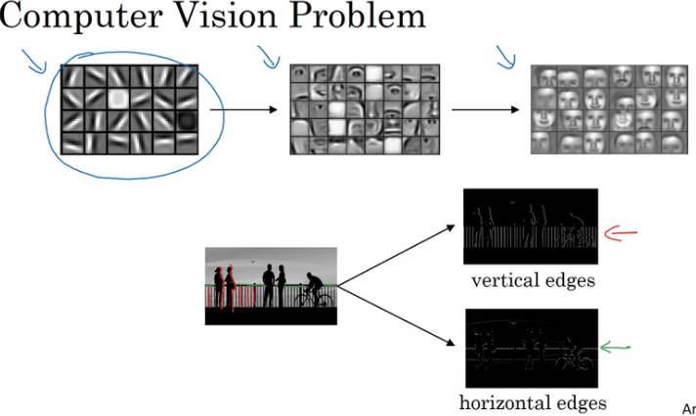

Given a picture like that for a computer to figure out what are the objects in this picture, the **first thing you might do is maybe detect vertical edges in this image**

Filter= kernel

## Vertical Edge Detector

Element wise multiplication

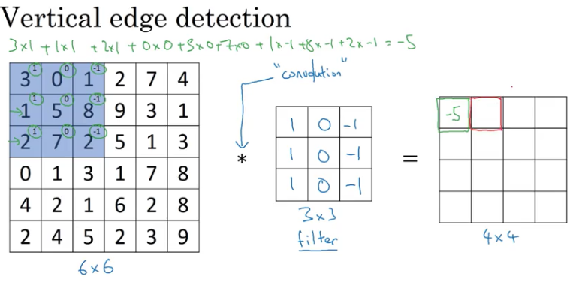

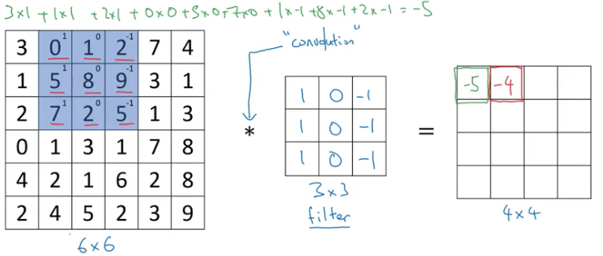

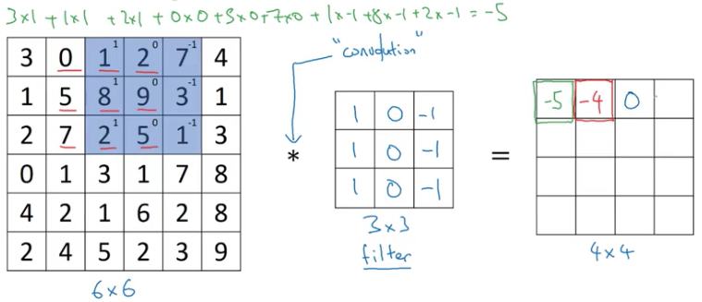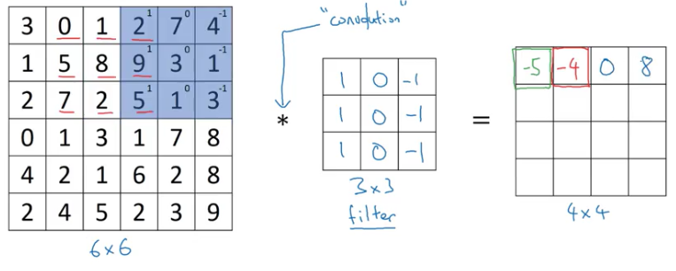

…

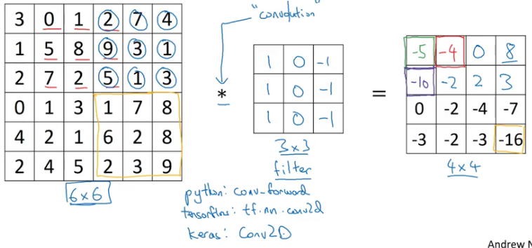

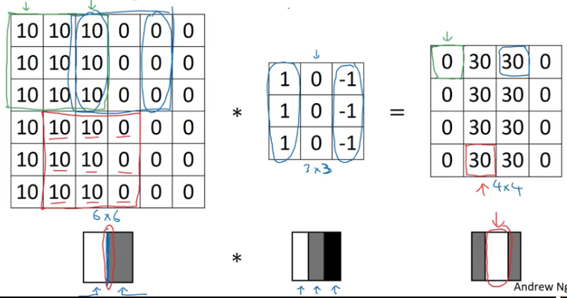

In this example, this bright region in the middle is just the output images way of saying that it looks like there is a strong vertical edge right down the middle of the image.

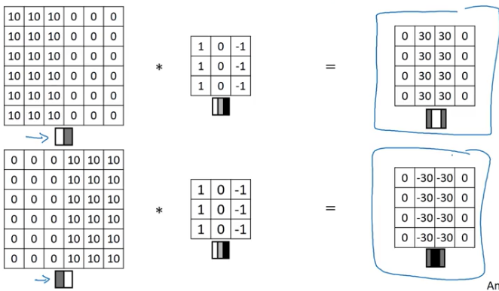

Zeros darker sides of pic, ones brighter

-30 here corresponds to a region, which is actually brighter on the bottom and darker on top. So that is a negative edge in this example

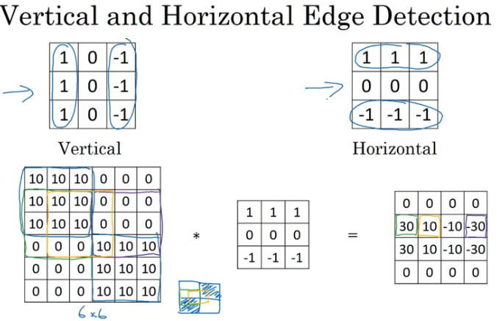

So in summary, different filters allow you to find vertical and horizontal edges.

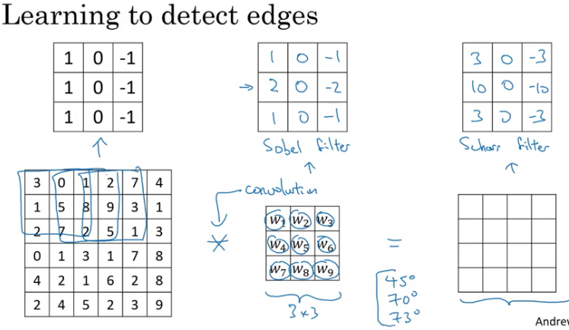

* So the idea you can treat **these nine numbers as parameters to be learned has** been one of the most powerful ideas in computer vision. And later in this course, later this week, we'll actually talk about the details of how you actually go about using **back propagation to learn these nine numbers.**

## Padding

Doldurma, tampon koyma

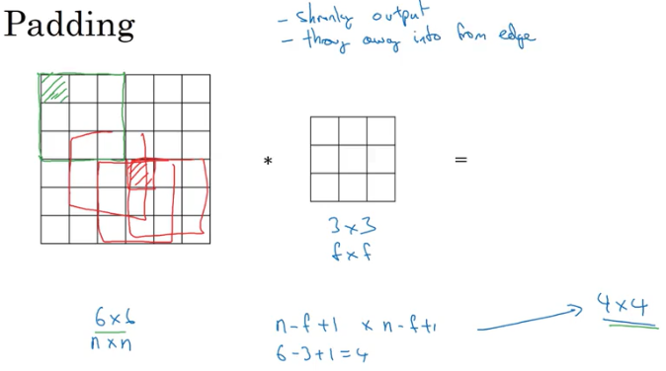

* What we saw in earlier videos is that if you take a six by six image and convolve it with a three by three filter, you end up with a four by four output with a four by four matrix, and that's because the number of possible positions with the three by three filter, there are only, sort of, **four by four possible positions**, for the three by three filter to fit in your six by six matrix.
* Two problems:
  + **Every time you apply a convolutional operator, your image shrinks**, so you come from six by six down to four by four then, you can only do this a few times before your image starts getting really small, maybe it shrinks down to one by one or something
  + Second downside is that, if you look the pixel at the corner or the edge**, this little pixel is touched as used only in one of the outputs,** because this touches that three by three region. Whereas, if you take a pixel in the middle, say this pixel, **then there are a lot of three by three regions that overlap that pixel** and so, is as if pixels on the corners or on the edges are use much less in the output. So you're throwing away a lot of the information near the edge of the image.
* So in order to fix both of these problems, what you can do is the full apply of convolutional operation. **You can pad the image**. So in this case, let's say you pad the image with an additional one border, with the additional border of one pixel all around the edges. So, if you do that, then instead of a six by six image, you've now padded this to eight by eight image and if you convolve an eight by eight image with a three by three image you now get that out.
* Now, the four by four by the six by six image, so you managed to preserve the original input size of six by six.
* Padding=1 in this example, because we added only one pixel border all around the image.

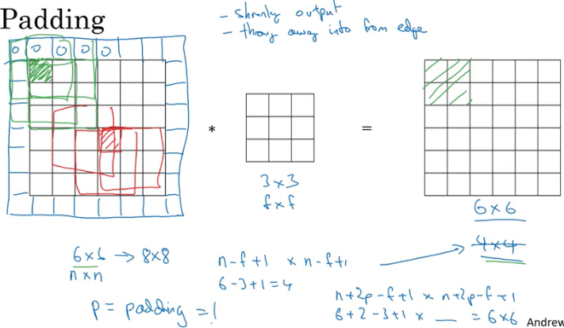

## Valid and Same Convolutions

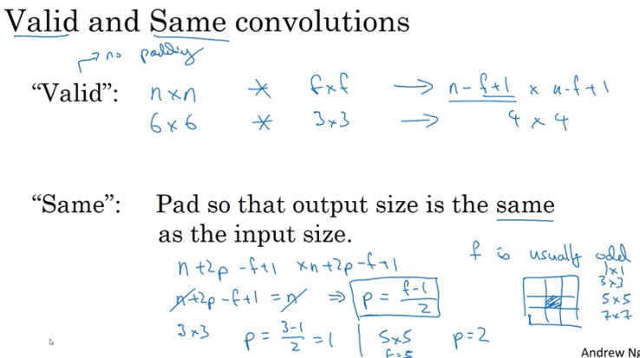

## Strided Convolution

Uzun adımlı, atlamalı, ileri atılan adım; Stride=2 means jumping two cells in each step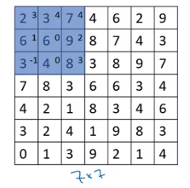 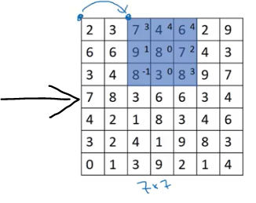

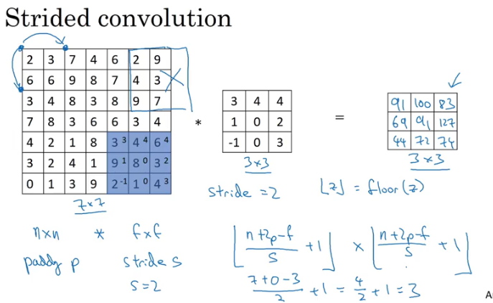

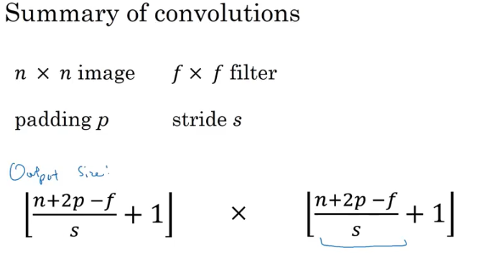

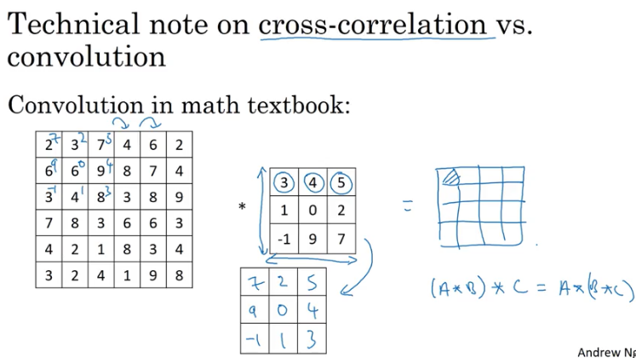

## Conv. On RGB Image

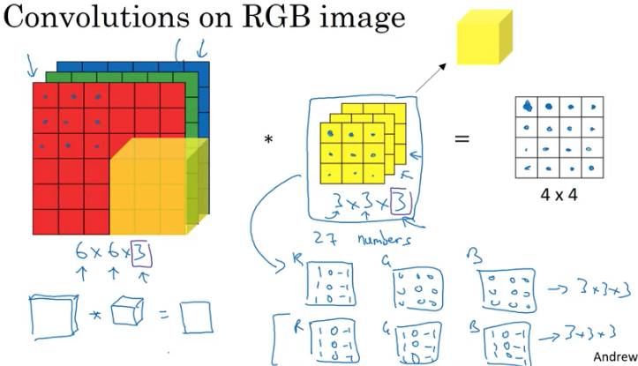

What if we wanted to detect vertical edges and horizontal edges and maybe 45 degree edges and maybe 70 degree edges as well

What if you want to use multiple filters at the same time?

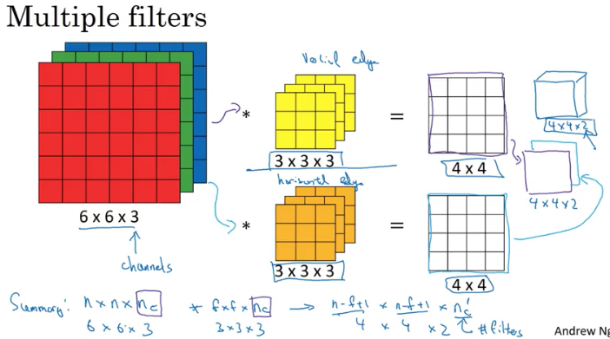

## One Layer of a Convolutional Network

a0= 6x6x3 to a1= 4x4x2

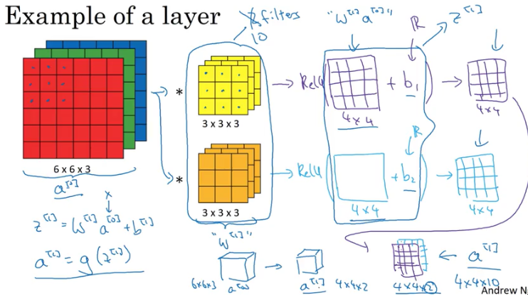

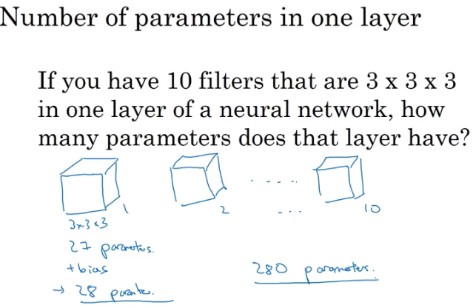

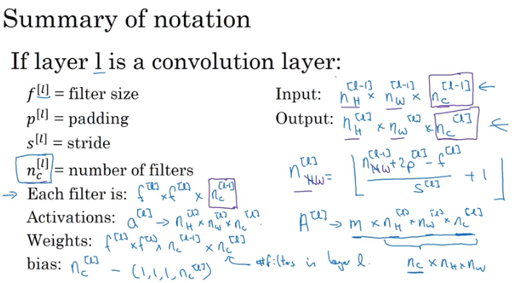

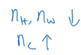

## ConvNet Example

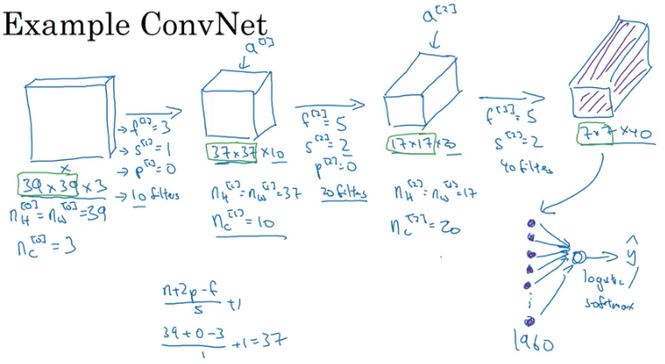

* You start off with larger images, 39 by 39. And then the height and width will stay the same for a while and gradually trend down as you go deeper in the neural network.
* It's gone from 39 to 37 to 17 to 7. Whereas **the number of channels will generally increase**. It's gone from 3 to 10 to 20 to 40, and you see this general trend in a lot of other convolutional neural networks as well.
* Height &width decrease, filter
* And it turns out that in a typical ConvNet, there are usually three types of layers.
  + Convolutional Layer -CONV
  + Pooling layer - POOL
  + Fully connected layer-FC

## Pooling Layer

ConvNets often also use pooling layers

* **to reduce the size of the representation,**
* **to speed the computation,**
* **Make some of the features that detects a bit more robust.**

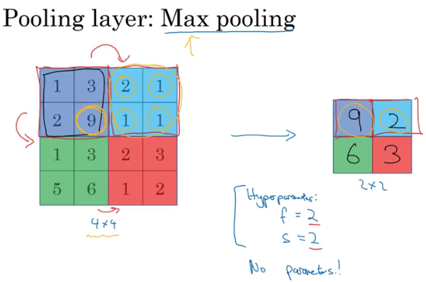

One interesting property of max pooling is that it has a set of hyperparameters but **it has no parameters to learn**. There's actually nothing for gradient descent to learn. Once you fix f and s, it's just a fixed computation and gradient descent doesn't change anything.

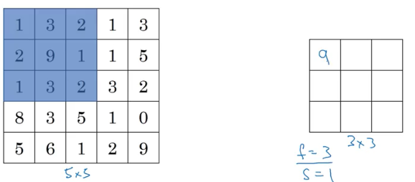 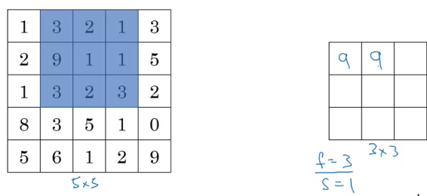 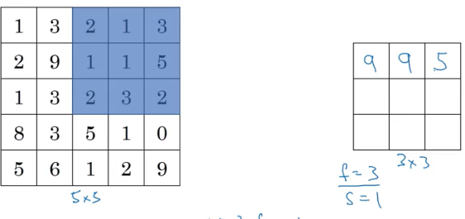

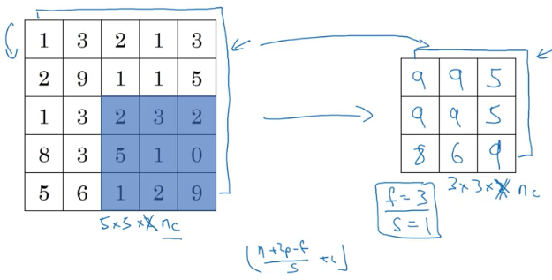

Average pooling isn’t used very often

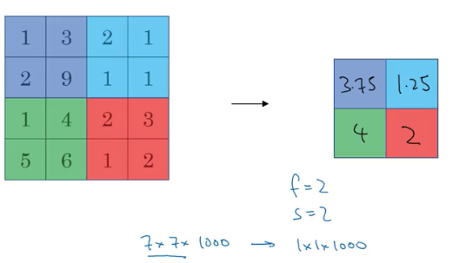

Padding is not used often

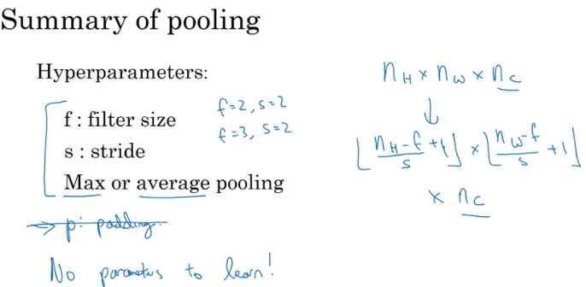

## Convolutional NN Example

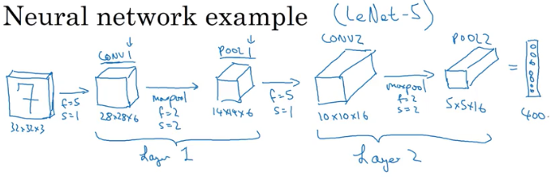

FC3 (fully connected layer) 400 units densely connected to 120 units.

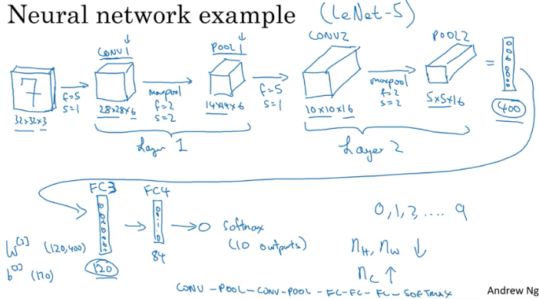

Height and width decrease in each layer forward while channel increases.

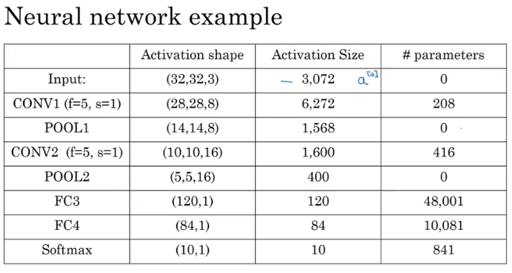

## Why convolutions?

büklüm, sarım, kıvrım, halka, dolambaç, kangal, helezon.

The advantages are parameter sharing and sparsity(dağınıklık, seyreklik) of connections.

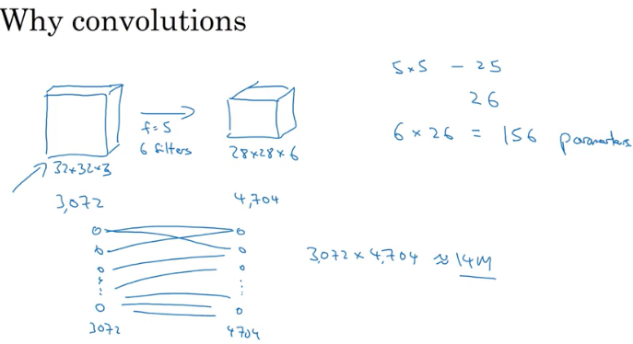

* 3,072 x 4,704 which is about 14 million; So, that's just a lot of parameters to train.
* And of course, if this were to be 1,000 by 1,000 image, then your display matrix will just become invisibly large.
* But if you look at the number of parameters in this convolutional layer, each filter is five by five. So, each filter has 25 parameters, plus a bias parameter miss of 26 parameters per a filter, and you have six filters, so, the total number of parameters is that, which is equal to **156 parameters**. And so, the number of parameters in this **conv layer remains quite small**
* The reason that a convnet has run to these small parameters is really two reasons.

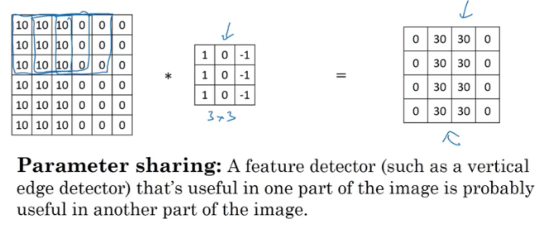

* + **One is parameter sharing**.

And parameter sharing is motivated by the observation that feature detector such as vertical edge detector, that's useful in one part of the image is probably useful in another part of the image. And what that means is that, if you've figured out say a three by three filter for detecting vertical edges, you can then apply the same three by three filter over here, and then the next position over, and the next position over, and so on. And so, each of these feature detectors, each of these aqua's **can use the same parameters in lots of different positions** in your input image in order to detect say a vertical edge or some other feature

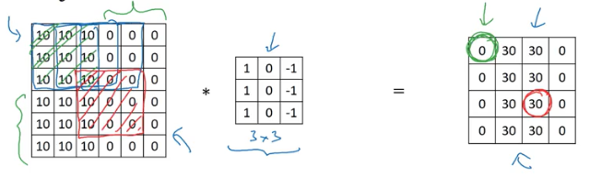

* + **Sparsity of connections**

The zero on the left 4x4 matrix depends only on 3x3 corner of bigger matrix 6x6

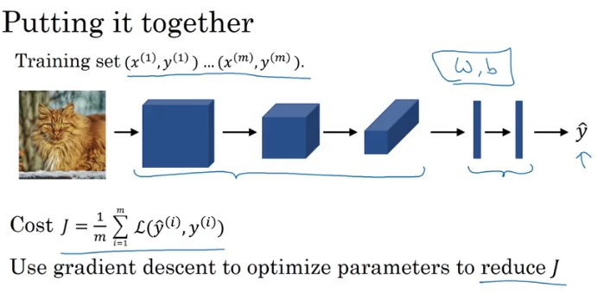

To train this neural network, all you need to do is then use gradient descents or some of

the algorithm like, gradient descent momentum, or RMSProp or Adam, or something else,

in order to optimize all the parameters of the neural network to try to reduce the cost function J.

In modern deep learning frameworks, you only have to implement the forward pass, and the framework takes care of the backward pass, so most deep learning engineers don't need to bother with the details of the backward pass

# W2

## Case Studies

* Classic Networks:
  + LeNet-5 : Handwritten digit recognition
  + AlexNet
  + VGG
* ResNet – 152 layer NN

## Classic Networks

### LeNet - 5

* When this paper was written **in 1998, people use average pooling much more.** If you're building a modern variant, you probably use **max pooling** instead.

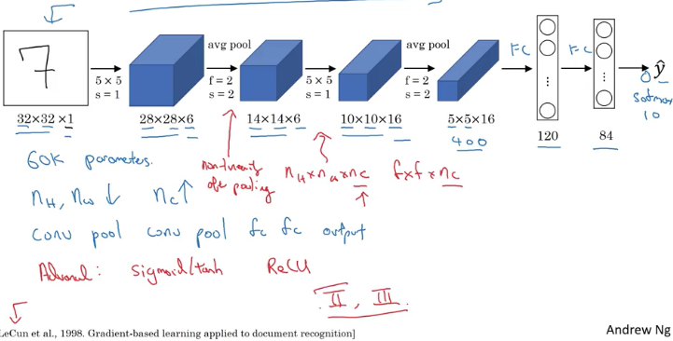

* In 1998, people didn't really use padding or you always using valid convolutions, which is why every time you apply convolutional layer, they heightened with strengths
* There's a fully connected layer and then another a fully connected layer. And then the final step is it uses these essentially 84 features and uses it with one final output. I guess you could draw one more node here to make a prediction for ŷ.
* And ŷ took on 10 possible values corresponding to recognizing each of the digits from 0 to 9.
* A modern version of this neural network, we'll use a softmax layer with a 10 way classification output.
* Although back then, LeNet-5 actually use a different classifier at the output layer, one that's useless today.
* So this neural network was small by modern standards, had about 60,000 parameters. And today, you often see neural networks with anywhere from 10 million to 100 million parameters, and it's not unusual to see networks that are literally about a thousand times bigger than this network.
* So you went from 32 by 32, to 28 to 14, to 10 to 5, whereas the number of channels does increase (1 to 6 to 16)
* It actually uses sigmoid non-linearity after the pooling layer.

### AlexNet

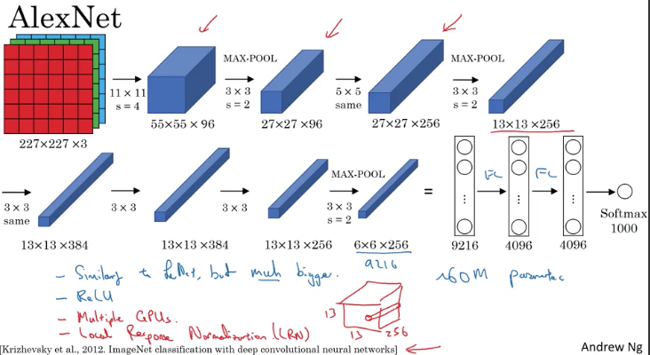

* So this neural network actually had a lot of similarities to LeNet, but it was much bigger. So whereas the LeNet-5 from previous slide had about 60,000 parameters, this AlexNet that had about **60 million parameters**.
* And the fact that they could take pretty similar basic building **blocks that have a lot more hidden units and training on a lot more data, they trained on the image that dataset that allowed it to have a just remarkable performance**.
* Another aspect of this architecture that made it much better than LeNet was using the **RELU activation function**

#### Local Response Normalization

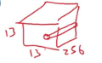

* + If you look at one of these blocks, one of these volumes that we have on top, let's say for the sake of argument, this one, 13 by 13 by 256, what Local Response Normalization, (LRN) does, is you look at one position. So one position height and width, and look down this across all the channels, **look at all 256 numbers and normalize them**. And the motivation for this Local Response Normalization was that for each position in this 13 by 13 image, maybe you don't want too many neurons with a very high activation
  + The motivation for this Local Response Normalization was that for each position in this 13 by 13 image, maybe you don't want too many neurons with a very high activation. But subsequently, many researchers have found that this doesn't help that much

### VGG

Instead of having so many hyperparameters in AlexNet, they used a much simpler network where you focus on just having conv-layers that are just three-by-three filters with a stride of one and always use same padding. And make all your max pulling layers two-by-two with a stride of two. And so, one very nice thing about the VGG network was it really simplified this neural network architectures.

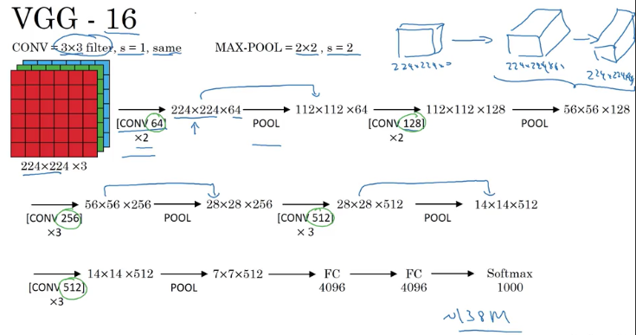

And you could see the details in the paper cited at the bottom by Karen Simonyan and Andrew Zisserman. But because VGG-16 does almost as well as VGG-19. A lot of people will use VGG-16. But the thing I liked most about this was that, this made this pattern of how, as you go deeper and height and width goes down, **it just goes down by a factor of two each time for the pulling layers whereas the number of channels increases.** And here roughly goes up by a factor of two every time you have a new set of conv-layers. So by making the rate at which it goes down and that go up very systematic,

I thought this paper was very attractive from that perspective. So that's it for the three classic architecture's. If you want, you should really now read some of these papers. I recommend starting with the AlexNet paper followed by the VGG net paper and then the LeNet paper is a bit harder to read but it is a good classic once you go over that. But next, let's go beyond these classic networks and look at some even more advanced, even more powerful neural network architectures. Let's go into.

## ResNets-Residual Networks

Very, very deep neural networks are difficult to train because of vanishing and exploding gradient types of problems. In this video, you'll learn about skip connections which allows you to take the activation from one layer and suddenly feed it to another layer even much deeper in the neural network. And using that, you'll build ResNet which enables you to train very, very deep networks.

### Residual Block

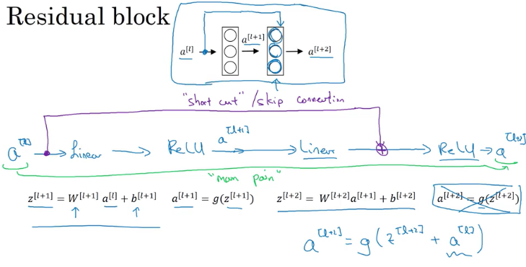

Shortcut: Rather than needing to follow the main path, the information from a[l] can now follow a shortcut to go much deeper into the neural network. And what that means is that this last equation goes away and we instead have that the output a[l+2] is the ReLU non-linearity g applied to z[l+2] as before, but now plus a[l].

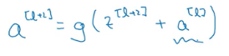

So, the addition of this a[l] here above, it makes this a residual block.

So a[l] is being injected after the linear part but before the ReLU part

What they found was that using residual blocks allows you to train much deeper neural networks. And the way you build a ResNet is by taking many of these residual blocks, blocks like these, and stacking them together to form a deep network.

Plain Network:

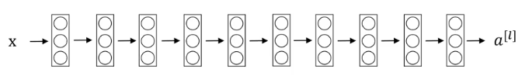

To turn this into a ResNet, what you do is you add all those skip connections although those short like a connections like so. So every two layers ends up with that additional change that we saw on the previous slide to turn each of these into residual block.

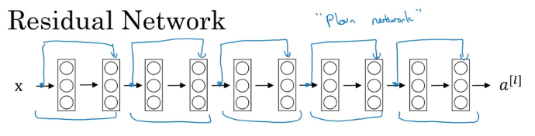

So this picture shows five residual blocks stacked together, and this is a residual network.

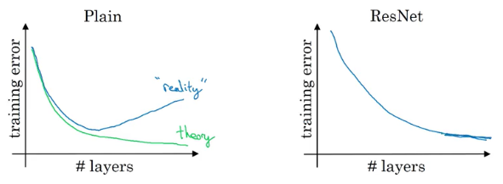

* Empirically, you find that **as you increase the number of layers, the training error will tend to decrease after a while but then they'll tend to go back up.** And in theory as you make a neural network deeper, it should only do better and better on the training set.
* **Having a plain network that is very deep means that all your optimization algorithm just has a much harder time training.**
* And so, in reality, your training error gets worse if you pick a network that's too deep.
* With **ResNet even as the number of layers gets deeper, you can have the performance of the training error kind of keep on going down**.
* Even if we train a network with over a hundred layers. And then now some people experimenting with networks of over a thousand layers although I don't see that it used much in practice yet. But by taking these activations be it X of these intermediate activations

and allowing it to go much deeper in the neural network, this really helps with the **vanishing and exploding gradient problems** and allows you to train much deeper neural networks without really appreciable loss in performance, and maybe at some point, this will plateau, this will flatten out, and it doesn't help that much deeper and deeper networks.

* **But ResNet is not even effective at helping train very deep networks**.

## Why ResNets Work

if you are using L2 regularization away to K, that will tend to shrink the value of w[l+2]

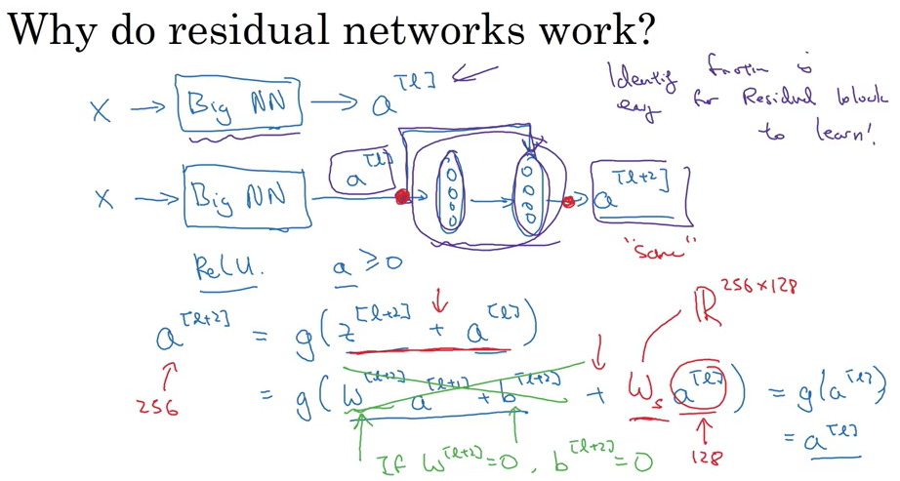

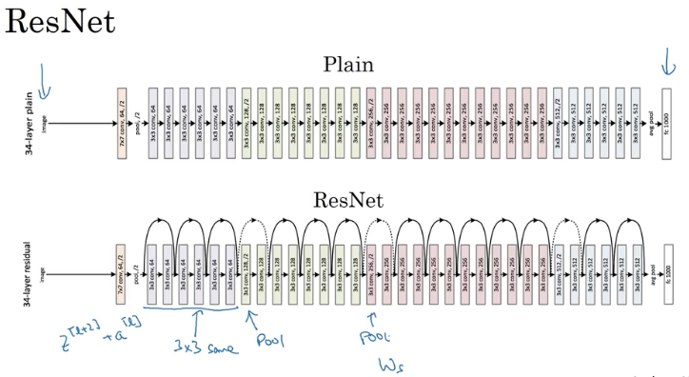

## 1x1 Convolutions

Network in network

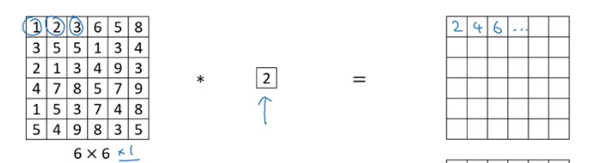

If there is only one channel, then this will be only multiplying all the matrix by 2.

But if you have 32 channel

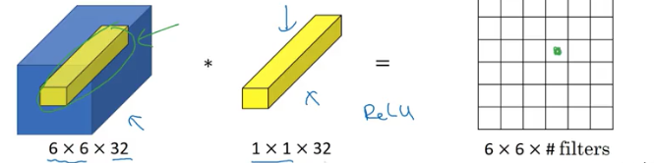

And in particular, what a one by one convolution will do is it will look at each of the 36 different positions here, and it will take the element wise product between 32 numbers on the left and 32 numbers in the filter. And then apply a ReLU non-linearity to it after that.

So, to look at one of the 36 positions, maybe one slice through this value, you take these 36 numbers multiply it by 1 slice through the volume like that, and you end up with a single real number which then gets plotted in one of the outputs like that.

And in fact, one way to think about the 32 numbers you have in this 1 by 1 by 32 filters is that,

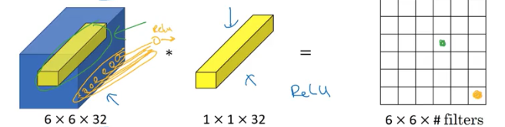

It's as if you have neuron that is taking as input, 32 numbers multiplying each of these 32 numbers in one slice of the same position heightened with by these 32 different channels, multiplying them by 32 weights and then applying a ReLU non-linearity to it and then outputting the corresponding thing over there.(above pic with yellow drawings)

--

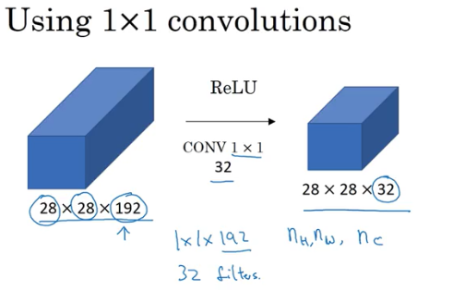

Let's say you have a 28 by 28 by 192 volume**. If you want to shrink the height and width, you can use a pooling layer.**

* But what will you do to shrink the number of channels?
  + Well, what you can do is use 32 filters that are one by one. And technically, each filter would be of dimension **1 by 1 by 192**, because the number of channels in your filter has to match the number of channels in your input volume,
  + But you use **32 filters** and the output of this process will be a 28 by 28 by 32 volume. So this is a way to let you shrink nc as well, whereas pulling layers, I used just to shrink nH and nW, the height and width these volumes. And we'll see later how this idea of one by one convolutions allows you to shrink the number of channels and therefore, save on computation in some networks.
  + And the effect of the one by one convolution is it just adds non-linearity. It allows you to learn the more complex function of your network by adding another layer that inputs 28 by 28 by 192 and outputs 28 by 28 by 192

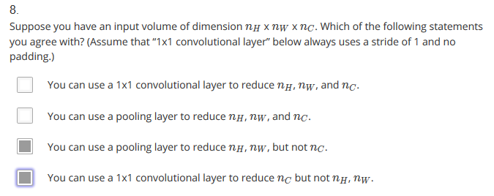

## Inception Network Motivation

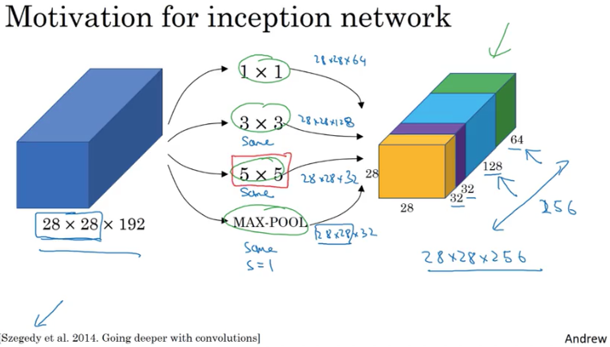

The basic idea is that **instead of you needing to pick one** of these filter sizes or pooling you want and committing to that, **you can do them all and just concatenate all the outputs, and let the network learn whatever parameters it wants to use**, whatever the combinations of these filter sizes it wants. Inception=başlangıç

There is a computational cost problem here. Next slide uses 5x5 example above

Total number of multiplies is 120Million (a pretty expensive even for modern computers)

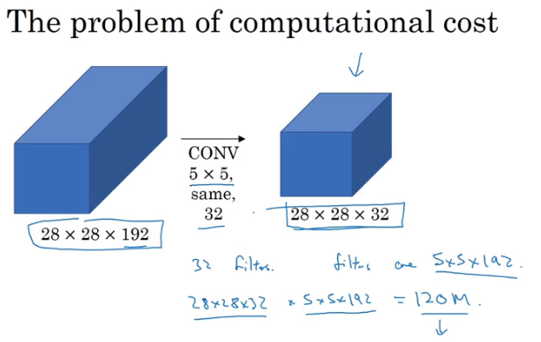

Here is an alternative architecture, same dimensions of input & output above (reduce 120M to 12.4M)

The middle layer is bottleneck layer

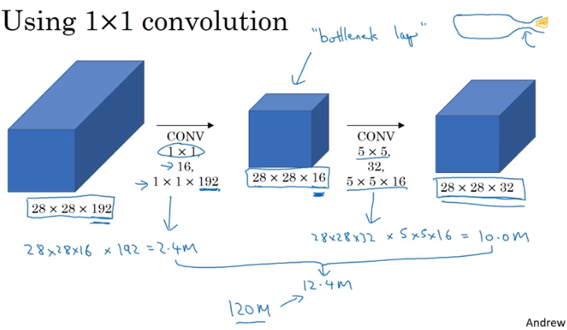

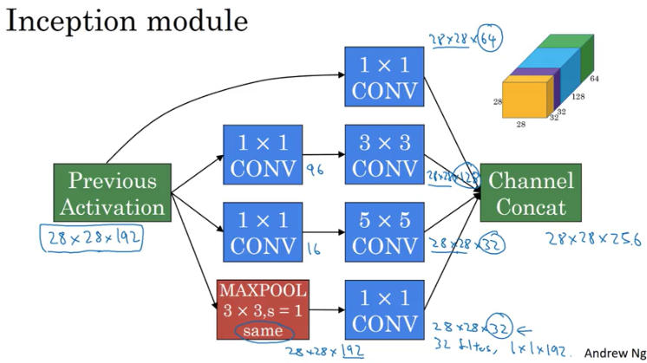

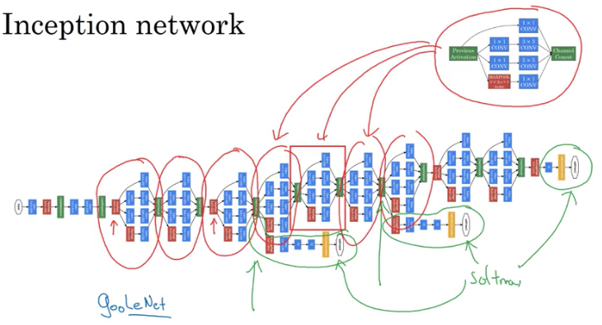

## Transfer Learning

You probably don't have a lot of pictures of Tigger or Misty so your training set will be small.

What can you do?

I recommend you go online and download some open source implementation of a neural network and download not just the code but also the weights.

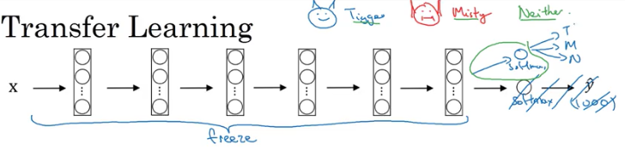

I'd encourage you to think of all of these layers as frozen so you freeze the parameters in all of these layers of the network and you would then just train the parameters associated with your softmax layer. Which is the softmax layer with three possible outputs, Tigger, Misty or neither.

Setting trainableparameter=0 you say don’t train this data.

For a bigger data you could do

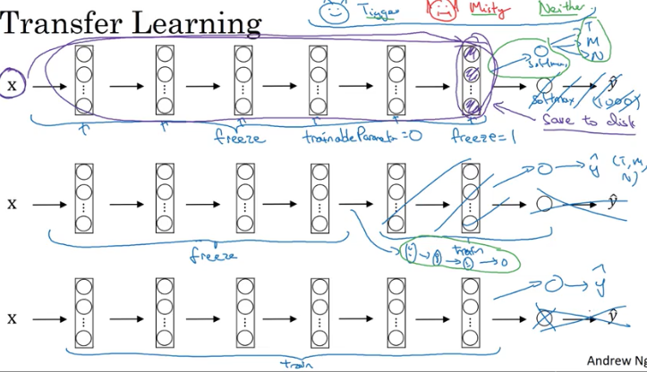

You can download that someone else has spent weeks training has learned from so much data, you find that for a lot of computer vision applications, you just do much better if you download someone else's open source ways and use that as initialization for your problem.

## Data augmentation

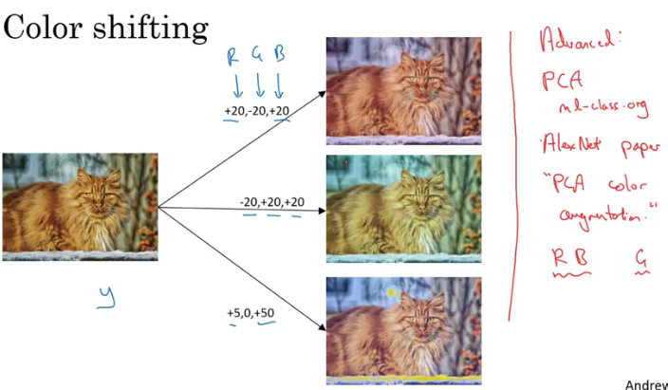

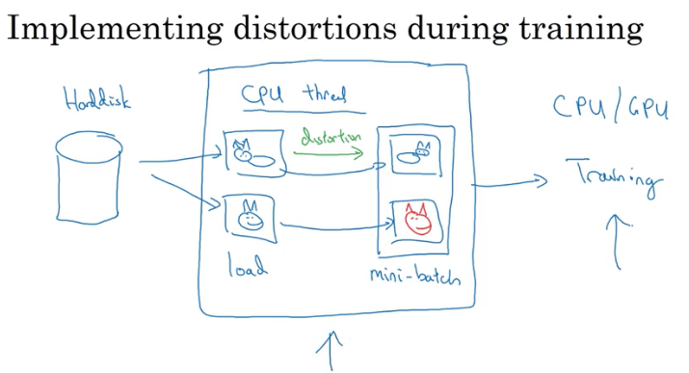

The data augmentation process also has a few hyperparameters such as how much color shifting do you implement and exactly what parameters you use for random cropping? So, similar to elsewhere in computer vision, a good place to get started might be to use someone else's open source implementation for how they use data augmentation.

## State of Computer Vision

Deep learning has been successfully applied to computer vision, natural language processing, speech recognition, online advertising, logistics, many, many, many problems. There are a few things that are unique about the application of deep learning to computer vision, about the status of computer vision.

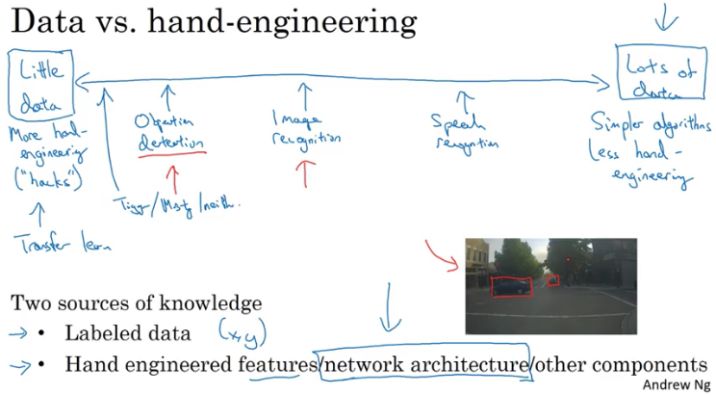

And even though in the last few years the amount of data with the right computer vision task has increased dramatically, I think that that has resulted in a significant reduction in the amount of hand-engineering that's being done. But there's still a lot of hand-engineering of network architectures and computer vision.

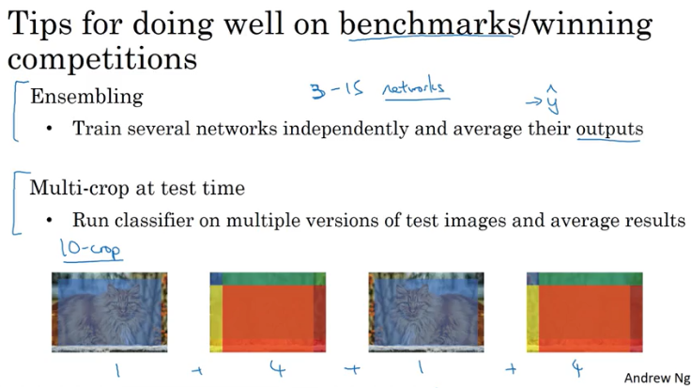

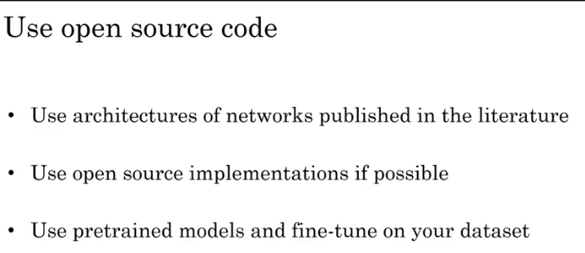

## Keras

* A high-level neural networks API (programming framework), written in Python and capable of running on top of several lower-level frameworks including TensorFlow and CNTK.
* Keras was developed to enable deep learning engineers to build and experiment with different models very quickly. Just as TensorFlow is a higher-level framework than Python, Keras is an even higher-level framework and provides additional abstractions. Being able to go from idea to result with the least possible delay is key to finding good models.
* However, Keras is more restrictive than the lower-level frameworks, so there are some very complex models that you can implement in TensorFlow but not (without more difficulty) in Keras. That being said, Keras will work fine for many common models.
* Keras is very good for rapid prototyping.
* Keras uses a different convention with variable names than we've previously used with numpy and TensorFlow.
* during each step of forward propagation, we are just writing the latest value in the computation into the same variable X

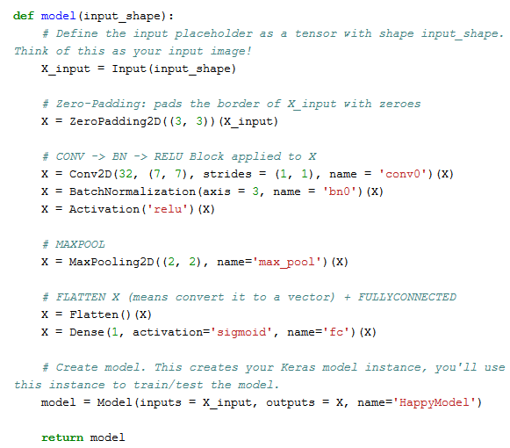







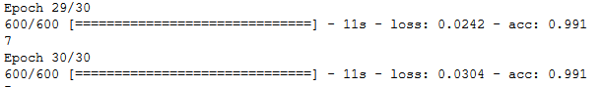

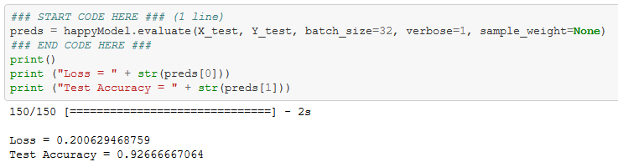

## Residual Networks Assignment

* The main benefit of a very deep network is that it can represent very complex functions. It can also learn features at many different levels of abstraction, from edges (at the lower layers) to very complex features (at the deeper layers).
* However, using a deeper network doesn't always help. A huge barrier to training them is vanishing gradients: very deep networks often have a gradient signal that goes to zero quickly, thus making gradient descent unbearably slow.
* More specifically, during gradient descent, as you backprop from the final layer back to the first layer, you are multiplying by the weight matrix on each step, and thus the gradient can decrease exponentially quickly to zero (or, in rare cases, grow exponentially quickly and "explode" to take very large values).
* During training, you might therefore see the magnitude (or norm) of the gradient for the earlier layers descrease to zero very rapidly as training proceeds:

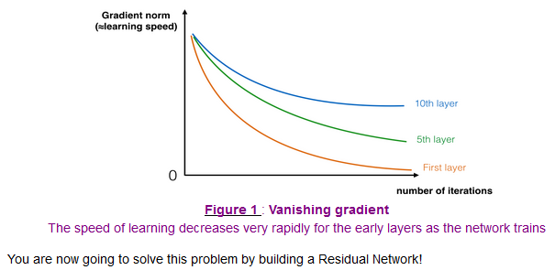

The image on the left shows the "main path" through the network. The image on the right adds a shortcut to the main path. By stacking these ResNet blocks on top of each other, you can form a very deep network.

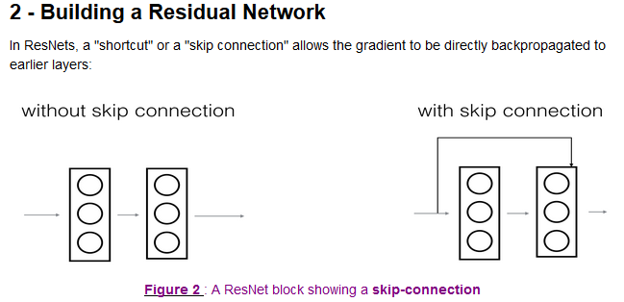

We also saw in lecture that having ResNet blocks with the shortcut also makes it very easy for one of the blocks to learn an identity function. This means that you can **stack on additional ResNet blocks with little risk of harming training set performance.** (There is also some evidence that the ease of learning an identity function--even more than skip connections helping with vanishing gradients--accounts for ResNets' remarkable performance.)

Two main types of blocks are used in a ResNet, depending mainly on whether the input/output dimensions are same or different. You are going to implement both of them.

### The identify block

The identity block is the standard block used in ResNets, and corresponds to the case where the input activation (say a[l]a[l]) has the same dimension as the output activation (say a[l+2]a[l+2]). To flesh out the different steps of what happens in a ResNet's identity block, here is an alternative diagram showing the individual steps:

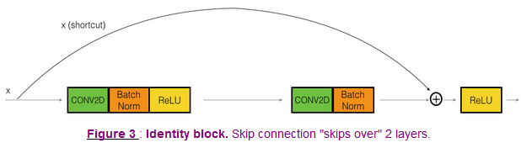

The upper path is the "shortcut path." The lower path is the "main path." In this diagram, we have also made explicit the CONV2D and ReLU steps in each layer. To speed up training we have also added a BatchNorm step. Don't worry about this being complicated to implement--you'll see that BatchNorm is just one line of code in Keras!

In this exercise, you'll actually implement a slightly more powerful version of this identity block, in which the skip connection "skips over" 3 hidden layers rather than 2 layers. It looks like this:

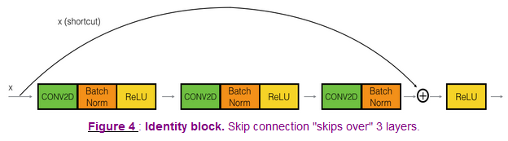

### Convolutional Block

The ResNet "convolutional block" is the other type of block. You can use this type of block when the **input and output dimensions don't match up.** The difference with the identity block is that there is a CONV2D layer in the shortcut path:

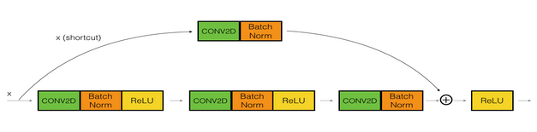

The CONV2D layer in the shortcut path is used to resize the input x to a different dimension, so that the dimensions match up in the final addition needed to add the shortcut value back to the main path. (This plays a similar role as the matrix W’s discussed in lecture.)

For example, to reduce the activation dimension's height and width by a factor of 2, you can use a 1x1 convolution with a stride of 2.

The CONV2D layer on the shortcut path does not use any non-linear activation function. Its main role is to just apply a (learned) linear function that reduces the dimension of the input, so that the dimensions match up for the later addition step.

# W3

## Object Localization

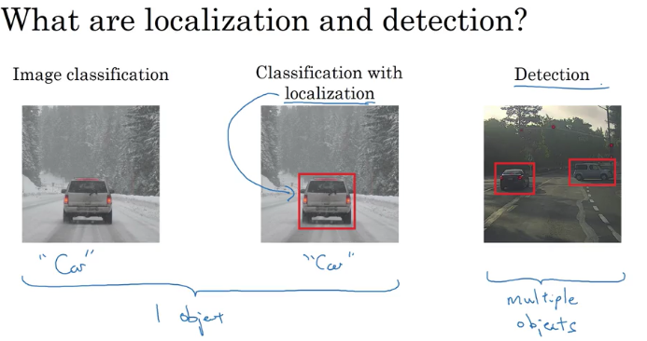

How about if you want to localize the car in the image as well. To do that, you can change your neural network to have a few more output units that output a bounding box (bx, by, bh, and bw. And these four numbers parameterized the bounding box of the detected object.)

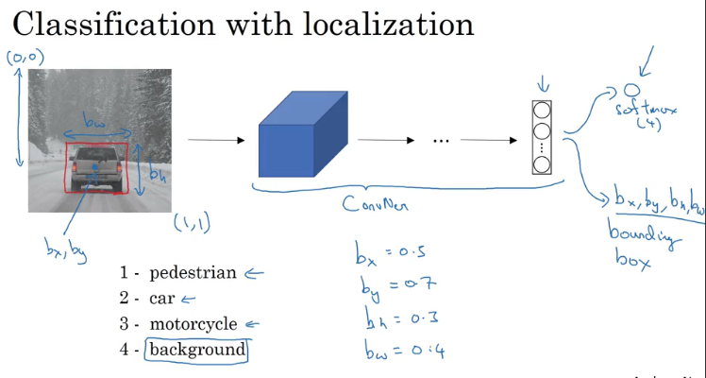

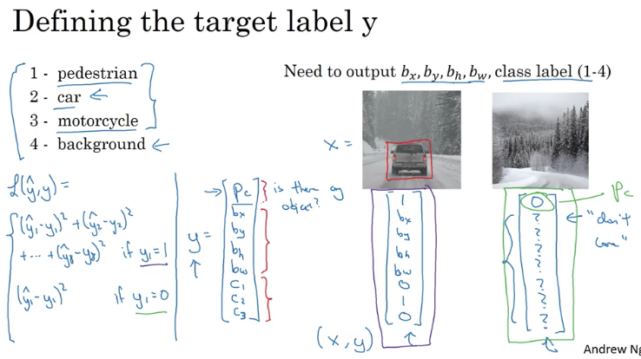

Pc: The first element is probability of is there an object (if 1,2,3 then it is 1, otherwise if 4 its value is 0)

If there is an object then c1,c2,c3 can be 1.

Y has 8 elements.

If y=0 then care about only the 1.st element, the others are not bothered.

## Landmark Detection

Sınır,

In the previous video, you saw how you can get a neural network to output four numbers of bx, by, bh, and bw to specify the bounding box of an object you want a neural network to localize.

In more general cases, you can have a neural network just output X and Y coordinates of important points and image, sometimes called **landmarks**, that you want the neural networks to recognize.

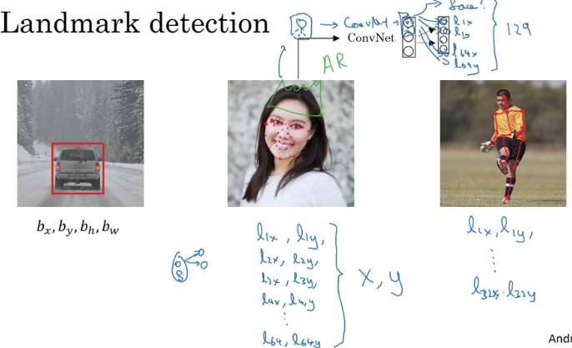

The identity of landmark one must be consistent across different images

## Object Detection

Perform object detection using the Sliding Windows Detection Algorithm.

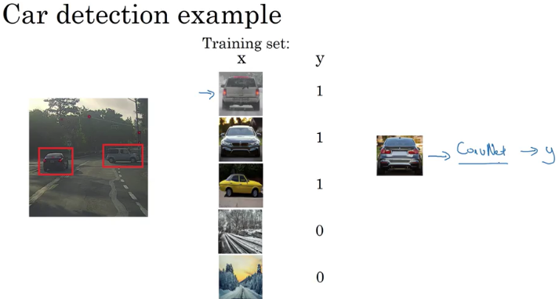

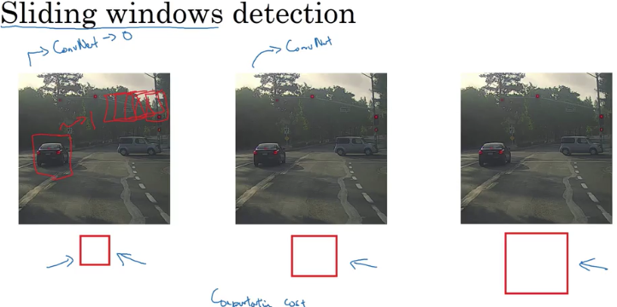

Small stride => computational cost increase; not able to localize objects accurately; you take every step and run a ConvNet. This will be a slow operation

Big stride => reduce the number of windows you need to pass

## Convolutional Implementation of Sliding Windows

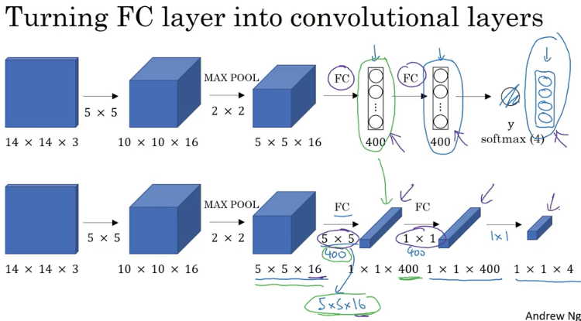

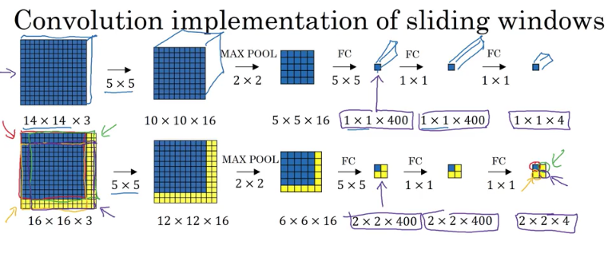

# W4

## One-shot learning

Learning from one example to recognize the person again

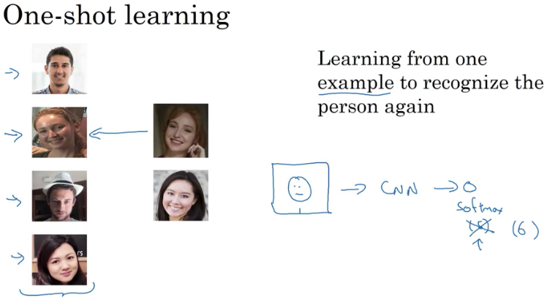

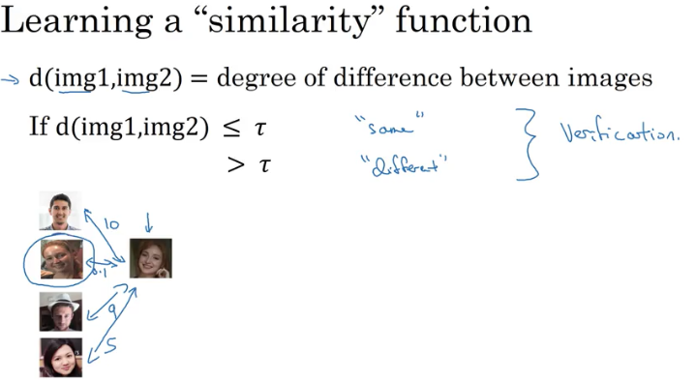

## Siamese network

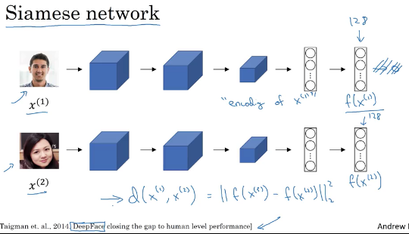

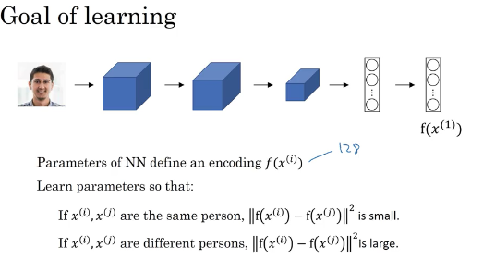

* What you want to do is learn parameters so that if two pictures, xi and xj, are of the same person, then you want that **distance** between their encodings to be **small**.
* If xi and xj are of **different** persons, then you want that **distance** between their encodings to be **large**.
* So as you vary the parameters in all of these layers of the neural network, you end up with different encodings. And what you can do is use back propagation and vary all those parameters in order to make sure these conditions are satisfied.

## Triplet Loss

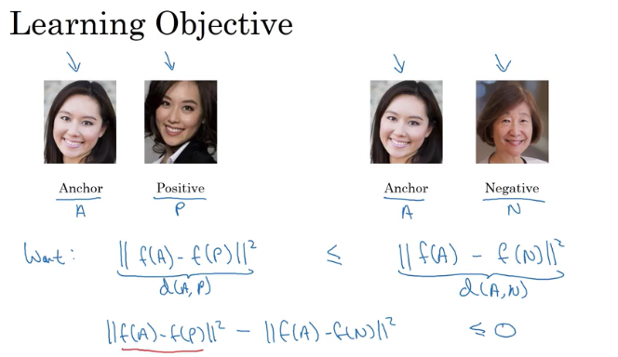

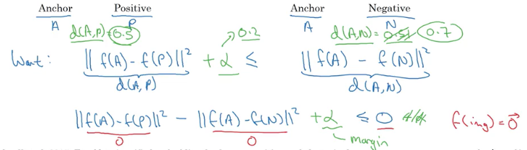

We want negative difference to be bigger than positive difference

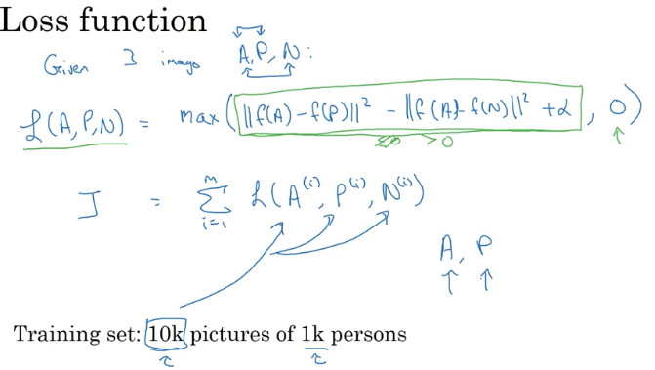

At least 10 different pictures of each person

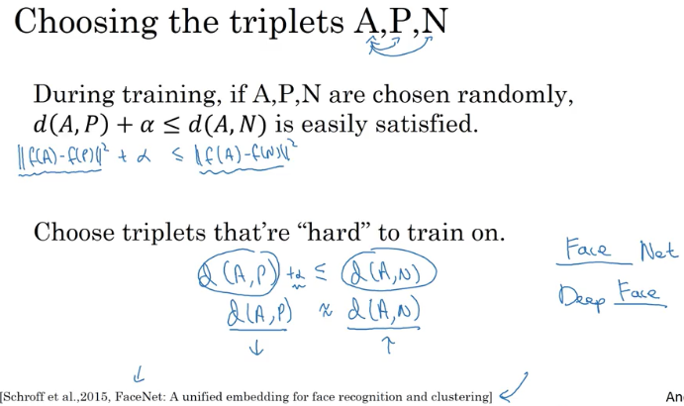

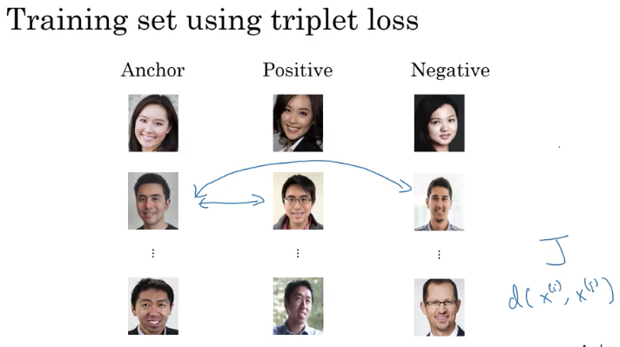

The Triplet Loss is one good way to learn the parameters of a ConvNet for face recognition.

## Face Verification&Binary Classification

The output is 1 if the two pics are of same person, 0 if different person; alternate to triple loss it is binary classification

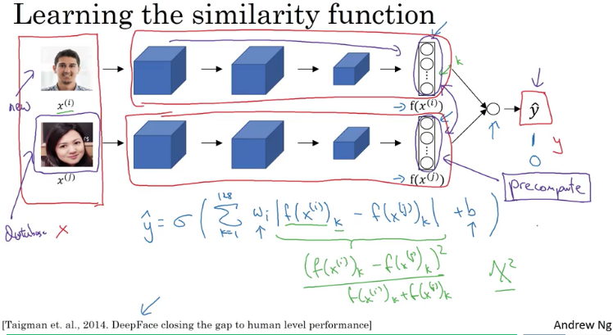

You're training is Siamese Network so that means that, this neural network up here has parameters that are what they're really tied to the parameters in this lower neural network.

So this is an employee (xi) walking in hoping that the turnstile the doorway will open for them and that this is from your database image. Then instead of having to compute, this embedding every single time, where you can do is actually pre-compute that, so, when the new employee walks in, what you can do is use this upper components to compute that encoding and use it, then compare it to your pre-computed encoding and then use that to make a prediction y hat.

Because you **don't need to store the raw images** and also because if you have a very large database of employees, you don't need to **compute these encodings every single time for every employee** database. This idea of free computing, some of these encodings can save a significant computation. And this type of pre-computation works both for this type of Siamese Central architecture where you treat face recognition as a binary classification problem, as well as, when you were learning encodings maybe using the Triplet Loss function as described in the last couple of videos.

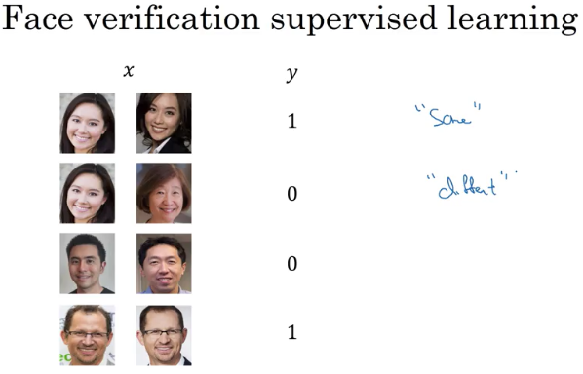

## Neural Style Transfer

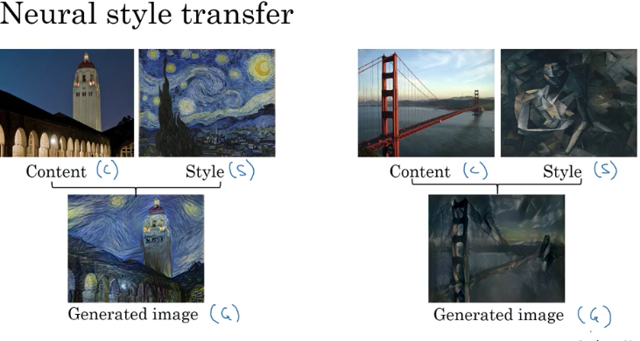

In order to implement Neural Style Transfer, you need to look at the features extracted by ConvNet at various layers, the shallow and the deeper layers of a ConvNet.

## What are deep ConvNets learning?

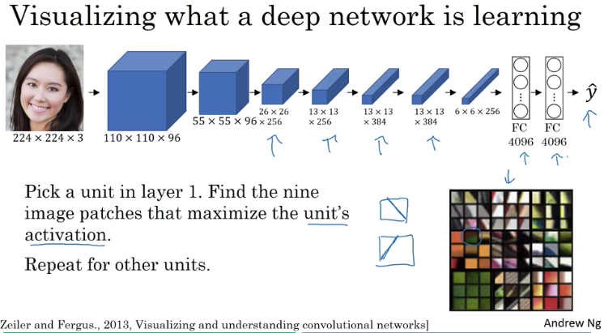

L**ayer 1, they're often looking for relatively simple features such as edge or a particular shade of color.**

**Deeper layers are looking for more complex features.**

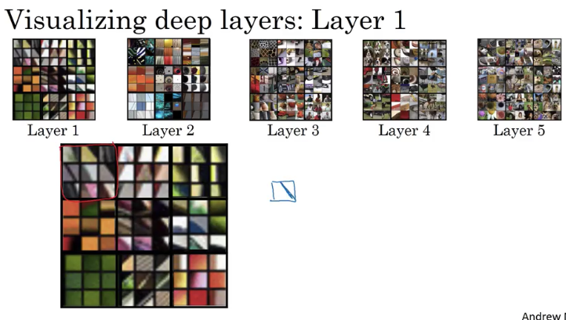 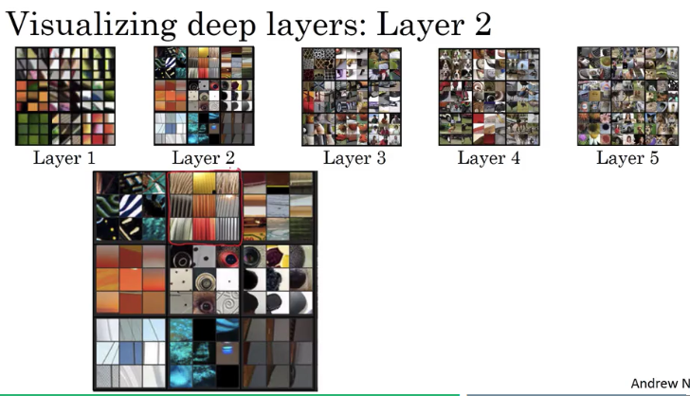

Layer1 Layer2

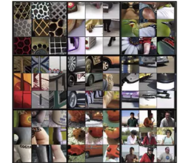 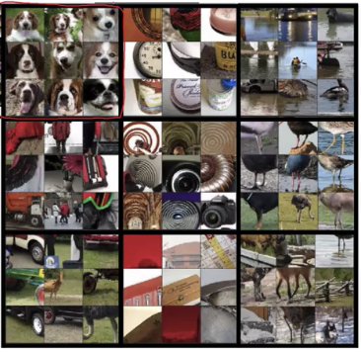 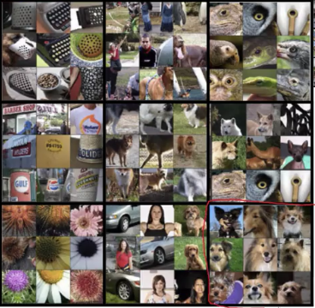

Layer3 Layer4 Layer 5

## Cost Function

Content= original picture

Style =the style wanted

Generated= converted picture with new style

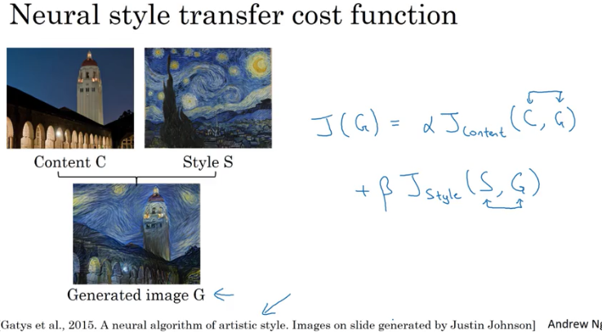

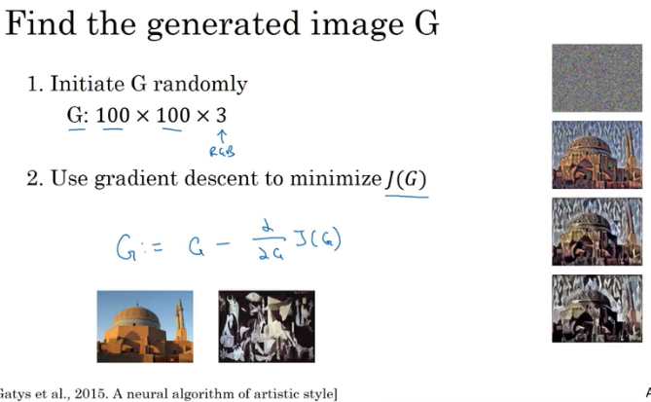

This is another probably Picasso image. Then when you initialize G randomly, you're initial randomly generated image is just this white noise image with each pixel value chosen at random.

As you run gradient descent, you minimize the cost function J of G slowly through the pixel value so then you get slowly an image that looks more and more like your content image rendered in the style of your style image.

In this video, you saw the overall outline of the Neural Style Transfer Algorithm where you define a cost function for the generated image G and minimize it.

* Two components
  + Content cost component
  + Style cost component

## Content Cost Function

This is the overall cost function of the Neural style transfer algorithm

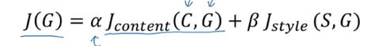

In practice, layer l chosen somewhere in between. It's neither too shallow nor too deep in the neural network.

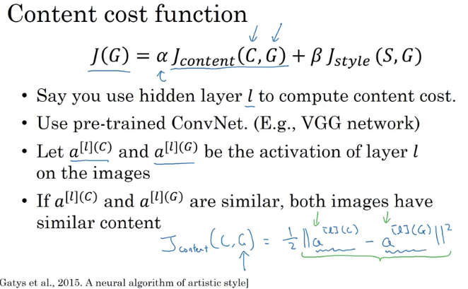

## Style cost component

Let's say you've chosen some layer L, maybe that layer to define the measure of the style of an image. What we need to do is define the style as the correlation between activations across different channels in this layer L activation.

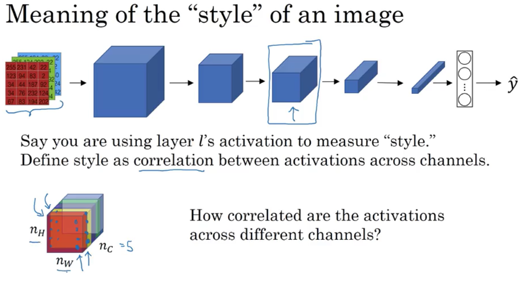

you just look at these two pairs of numbers(one in red channel, one in yellow channel) and see when you look across all of these positions, all of these nh by nw positions, how correlated are these two numbers

So, why does this capture style?

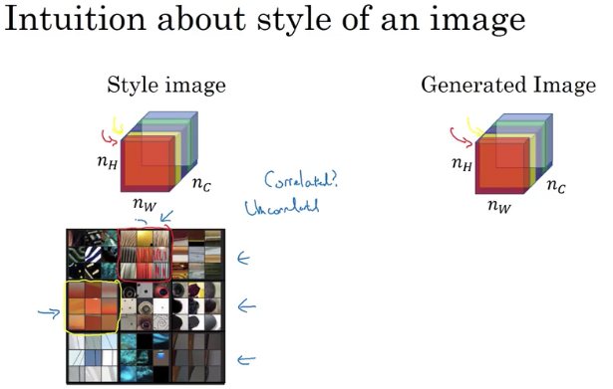

1.channel(red) corresponds to 2nd image’s 1.st row 2nd column

2.channel (yellow) corresponds to 2nd image’s 2nd row 1st column

What does it mean for these two channels to be highly correlated?

* they're highly correlated what that means is whatever part of the image has this type of subtle vertical texture, that part of the image will probably have these orange-ish tint.
* If uncorrelated , it means that whenever there is this vertical texture, it's probably won't have that orange-ish tint(the
* And so the **correlation tells** you which of these ***high level texture components tend to occur or not occur together in part of an image***
* that's the degree of correlation that gives you one way of measuring how often these different high level features, such as vertical texture or this orange tint how often they occur and how often they occur together and don't occur together in different parts of an image.

So what you can to do is given an image computes something called **a style matrix**, which will **measure all those correlations** we talks about on the last slide.

So what **the style matrix will do** is you're going to **compute a matrix clauses G superscript** square bracketed l. This is going to be **an nc by nc dimensional matrix**, so it'd be a square matrix

Remember you have nc channels and so you have an nc x nc dimensional matrix in order to measure how correlated each pair of them is

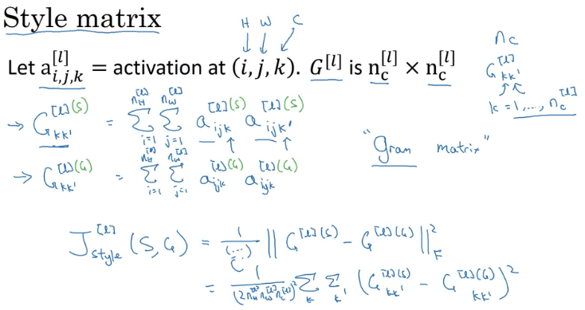

* 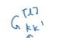 => **will measure how correlated are the activations in channel k compared to the activations in channel k prime**;
* It will be small if activations are not correlated, will be large if correlated.
* Örnek (1 ve 2.channel(nc) tüm height ve width’ler üstünden karşılaştırılıyor)
* Gram matrix= style matrix

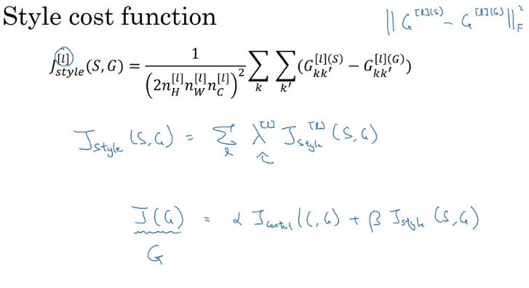

J overall style cost = sum of all level style costs multiplied by alpha.

If you want in order to try **to find an image G that normalize, that tries to minimize this cost function** j of G. And if you do that, you can generate pretty good looking neural artistic and if you do that you'll be able to generate some pretty nice novel artwork.

## 1D and 3D Generalizations

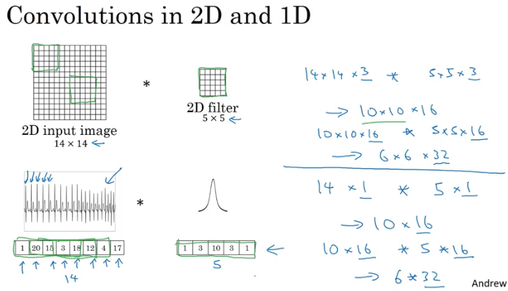

CAT scans, medical scans, movie data as one example of 3D volumes